GCSE English Literature
Exam Board | Eduqas
Exam Dates | LIT C1: Monday 13th May 2024 am- 2 hours  LIT C2: Monday 20th May 2024 am- 2 hours 30 mins

Breakdown of Examinations
Exam Title | Duration | Content
C1 – English Literature (40%) | 2 hours | Shakespeare & Poetry Anthology
C2 – English Literature (60%) | 2 hours 30 minutes | 20th Century text -‘Lord of the Flies’, 19th Century text– ‘Jekyll & Hyde’ OR ‘A Christmas Carol’ and Unseen Poetry
Recommended Revision Resources
Your son has already received their English subject KO. This KO covers all of the texts that will come up in their exams.
The KO is broken down into key sections and has a range of information about key characters, relationships and themes, as well as quotes and context.
Recommended Revision Websites
SHAKESPEARE (MACBETH) REVISION:
- http://nfs.sparknotes.com/macbeth/
- http://www.sparknotes.com/shakespeare/macbeth/
- http://www.shmoop.com/macbeth/
- http://www.bbc.co.uk/schools/gcsebitesize/english_literature/dramamacbeth/
- http://www.yorknotes.com/gcse/macbeth/revision-cards
- http://revisionworld.com/a2-level-level-revision/english-literature-gcse-level/macbeth-william-shakespeare

POETRY ANTHOLOGY REVISION:
- http://www.bbc.co.uk/education/subjects/zckw2hv
- http://www.sparknotes.com/poetry/
- http://www.shmoop.com/poetry/

LORD OF THE FLIES REVISION:
- http://www.bbc.co.uk/education/subjects/zckw2hv
- http://www.shmoop.com/lord-of-the-flies/
- http://www.sparknotes.com/lit/flies/

A CHRISTMAS CAROL REVISION:
- http://www.sparknotes.com/lit/christmascarol/
- http://www.shmoop.com/christmas-carol/
- http://www.bbc.co.uk/education/topics/zcs8qty
JEKYLL & HYDE REVISION:
- http://www.sparknotes.com/lit/jekyll/
- http://www.shmoop.com/jekyll-and-hyde/
- http://www.bbc.co.uk/schools/gcsebitesize/english_literature/prosejekyllhyde/

CONTEXTUAL REVISION FOR THE 19th CENTURY:
- http://www.bl.uk/victorian-britain
- http://www.nationalarchives.gov.uk/education/victorianbritain

UNSEEN POETRY REVISION
- http://www.bbc.co.uk/schools/gcsebitesize/english_literature/writingcomparingpoetry/
- http://www.bbc.co.uk/education/guides/z3gfg82/revision
- http://www.shmoop.com/poetry/
- http://www.poetryarchive.org/explore

Assessment Objectives
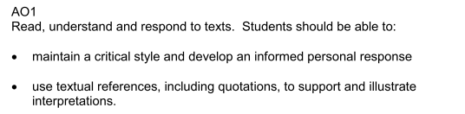
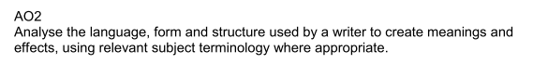
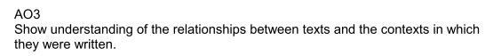
Independent Study / Revision
For each novel or play, you should collect evidence which allows you to discuss:
- Key characters
- Key relationships
- Key themes
in 5 different places across the text. You should collect significant quotes which allow you to discuss your thoughts on characters/relationships/themes and ensure you focus on specific language and structural devices. For the 19th Century novel, remember the WIDER CONTEXT – the writer’s time era and issues/personal circumstances/attitudes and intentions.

For poetry, re-read the 18 poems; group poems into themes (remembering that a poem can fall into several themes!) and select key quotes that enable you to discuss the theme, considering language and structural features as well. Remember the WIDER CONTEXT – the writer’s time era/personal circumstances/attitudes and intentions are also vital for success with poetry.

