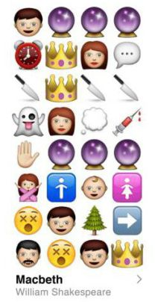
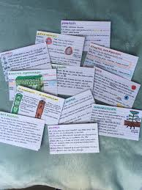
Mind maps, spider diagrams or posters of key ideas about characters, themes or relationships, which can include quotes.
Emojis to track character development (with quotes) or events
Flashcards about:
-key characters
-key events
-key quotes
-key themes
-key relationships
-context

EVIDENCE | EXPLANATION | IMPACT ON THE AUDIENCE OR READER
“solitary as an oyster”
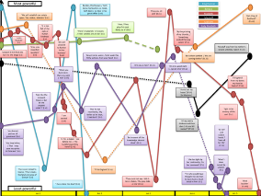
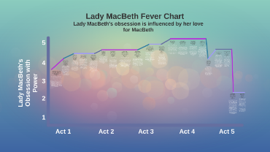
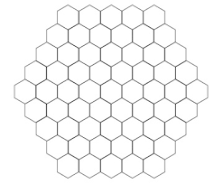
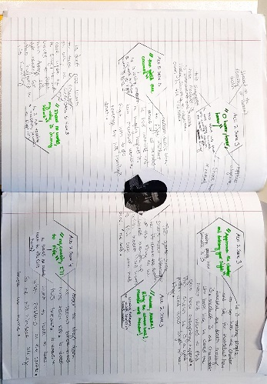
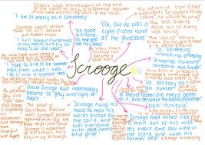
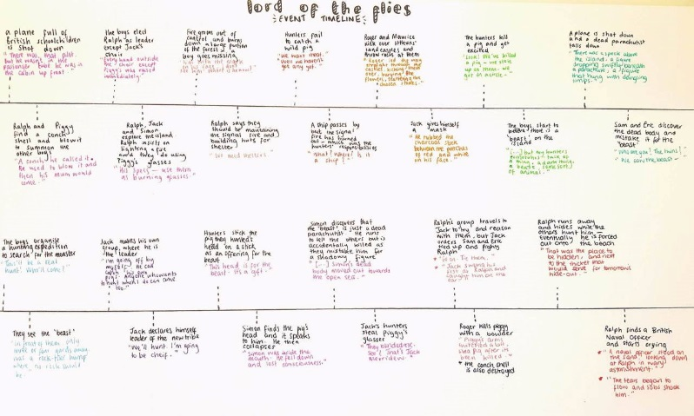
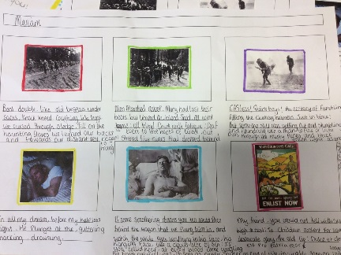
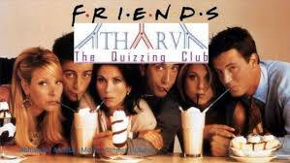
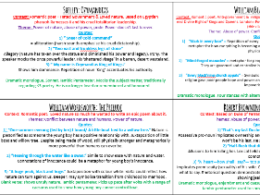
Charts to show how characters change, grow or fall throughout a text.
Hexagon grids to track character development across a text
Impact and evidence tables
A timeline of key events in the text – or perhaps a storyboard
Quizzing friends!

