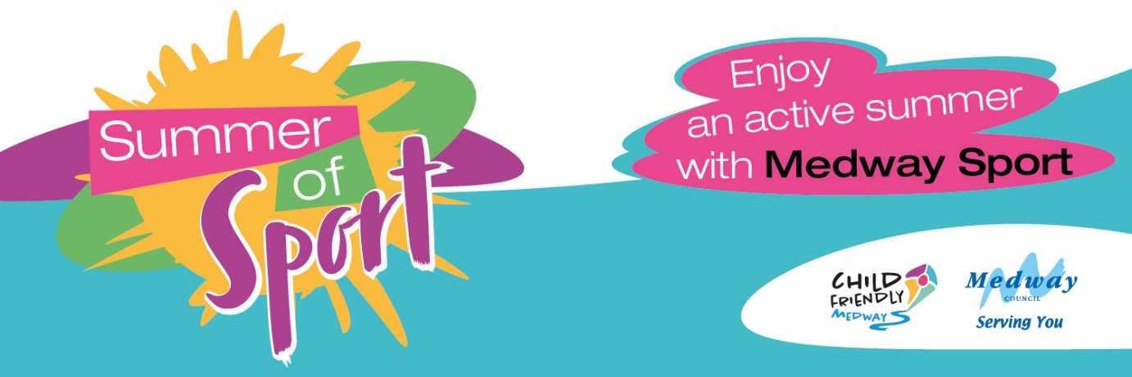

ParkSport
Weekly sessions of FREE informal pop-up sport and activities including football, rounders and tennis for all abilities and ages, taking place in Medway’s greenspaces. Sessions are sponsored by Child Friendly Medway and run weekly from Saturday 11 June throughout the summer months. No need to book, just pop along.

Drop-in football every Saturday from 11 June.

Location | Age Under 8s | Age 8-12
Rainham Rec | 10-11am | 11am-12pm
Gillingham Park | 12:30-1:30pm | 1:30-2:30pm
Liberty Park, Wainscott | 10-11am | 11am-12pm
Pottery Road, Hoo | 12:30-1:30pm | 1:30-2:30pm
Palmerston Rd, Chatham | 10-11am | 11am-12pm
Luton Rec, Chatham | 12:30-1:30pm | 1:30-2:30pm

Mid-week drop-in football

Location | Time | Age Group
Strood Sports Centre  Every Thursday | 4:30-5:30pm | 7-12
Watling Park 3G, Gillingham  Every Wednesday | 4:45-5:45pm | 7-12
Hook Meadow, Walderslade  Every Wednesday | 5:30 – 7:30pm | 10+

Family and friends tennis
Every Monday 4.30pm to 5.30pm age 5 to 11 years, 5.30pm to 6.30pm families aged 5 plus. Darnley Road Tennis Courts, Strood. From 11 July to 22 August.

Back to Netball (From age 16 plus)
Every Wednesday, The Strand Netball Court, Gillingham (from TBC)

Girls Football
Every Wednesday 5.30pm Strood Sports Centre (from 6 July)

The Big Kickabout
Every Friday 5.30pm Strood Sports Centre (from 10 June)

Family and friends rounders
Every Sunday, 2pm to 4pm Great Lines Park, Gillingham (from 24 July)

It’s Time to Try - Workout for Summer
Our team of fitness instructors are taking to the road this summer for some free pop-up community fitness sessions for all ages with Child Friendly Medway, such as aqua aerobics at The Strand, plus yoga, bootcamp, boxercise and circuits at other locations. Keep an eye on our social media for more information.

Every Monday
Paddleboarding and Kayaking with Chatham Maritime Trust, Community Watersports Centre, Maritime Way, Chatham ME4 4QT. 9.30am to 11am every Monday from 25 July to 22 August

Every Wednesday
4.30pm Family Bootcamp at Cosington Park, Rainham (from 8 June, age 11 plus)

Every Thursday
5.30pm Family Circuits at Church Green Rec, Frindsbury (from 9 June, age 5 plus)

Every Friday
5.30pm Family Boxercise at Broomhill Park (from 8th July, age 7 plus)

Every Saturday
9.15am Bootcamp at The Strand (from 2 July age 14 plus)
11.30am Aqua Aerobics at The Strand (every Saturday from 6 August. Strand entrance ticket required, class included in your entrance)

Every Saturday
2.30pm Yoga, Rochester Castle Gardens (from 16 July-13 August. Sessions for all ages including children)

Medway Mile
This year the Medway Mile is heading to Gillingham and will celebrate both the Queen’s Platinum Jubilee and this summer’s Commonwealth Games taking place on home soil. Free family sports, activities and entertainment, plus children’s races, competitive club track races and a mass mile taking in some of Brompton’s most treasured military landmarks.
Friday, 22 July from 5pm. Medway Park Sports Centre, Mill Road, Gillingham
Free. Register via medway.gov.uk/medwaymile from 22 May 2022

